Assignment 04

Student name: Phuong, Dinh Hoang Viet  
Student number: 301123263

1.

SELECT officer_ID, last_col, precinct, status

FROM officers

WHERE precinct IN ('OCVW', 'GHNT') AND status = 'A'

ORDER BY precinct, last_col  
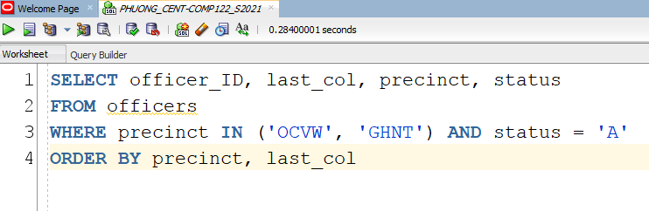

2.

SELECT officer_ID, last_col, first_col, status,

DECODE(SUBSTR(precinct,2,1), 'C', 'Community1','H','Community2','Default Community')

AS Community

FROM officers

WHERE status = 'A'

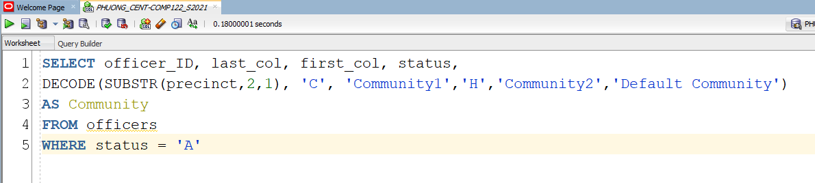

3.

SELECT charge_ID, crime_ID, fine_amount, court_fee, amount_paid,

(fine_amount + court_fee - amount_paid)

AS amount_owed

FROM crime_charges

WHERE (fine_amount + court_fee - amount_paid) > 0;

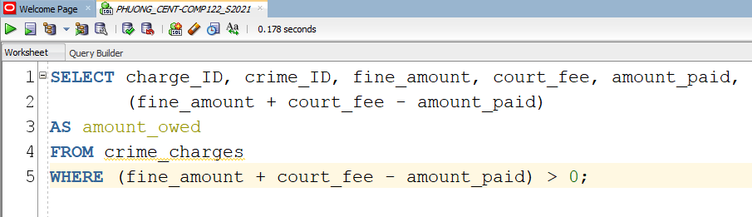

4.

SELECT cls.criminal_id, cls.first_col, cls.last_col, cc.crime_code, cc.fine_amount

FROM ((criminals cls

INNER JOIN crimes cr

ON cr.criminal_id = cls.criminal_id

)

INNER JOIN crime_charges cc

ON cc.crime_id = cr.crime_id

)

ORDER BY criminal_id, first_col, last_col, crime_code, fine_amount;

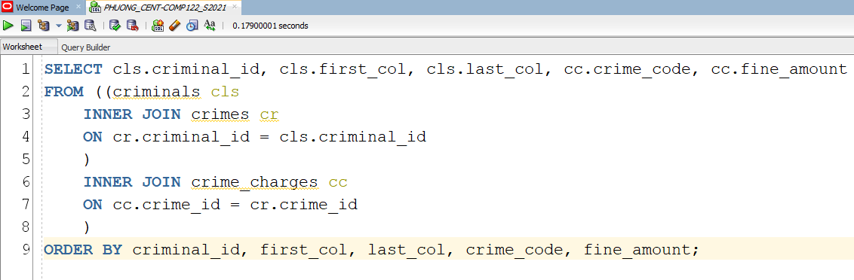

5.

SELECT cls.criminal_id, cr.classification, cr.data_changed, ap.filing_date, ap.status

FROM criminals cls

JOIN crimes cr ON cr.criminal_id = cls.criminal_id

JOIN appeals ap ON ap.crime_id = cr.crime_id

ORDER BY criminal_id;

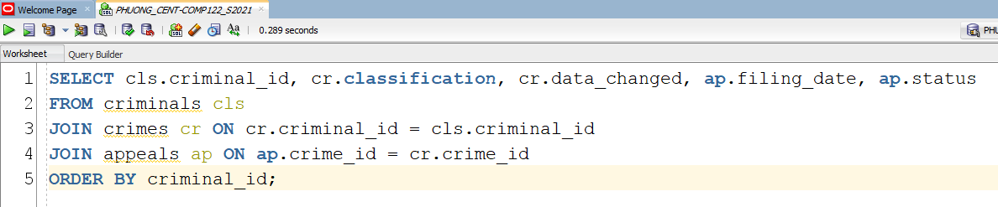

6.

SELECT cls.criminal_id, cr.classification, cr.data_changed,

cc.fine_amount, cc.crime_code FROM criminals cls JOIN crimes cr

ON cr.criminal_id = cr.criminal_id JOIN crime_charges cc

ON cc.crime_id = cr.crime_id

WHERE classification = 'O'

ORDER BY criminal_id

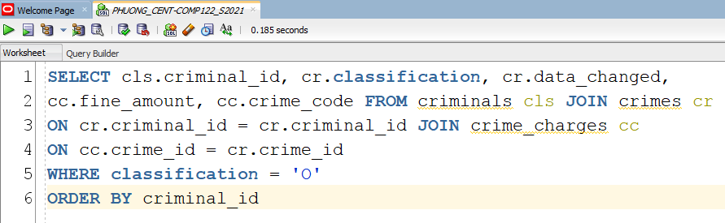

7.

CREATE TABLE aliases ( alias_ID numeric(6), criminal_ID numeric(6,0), alias_col VARCHAR(10) );

SELECT c.criminal_id, c.last_col, c.first_col, c.v_status, c.p_status, a.alias_ID

FROM criminals c, aliases a

WHERE c.criminal_id = a.criminal_id

ORDER BY c.last_col, c.first_col;

/*JOIN Method */

SELECT c.criminal_id, c.last_col, c.first_col, c.v_status, c.p_status, a.alias_ID

FROM criminals c LEFT OUTER JOIN aliases a

ON c.criminal_id = a.criminal_id ORDER BY last_col, first_col;

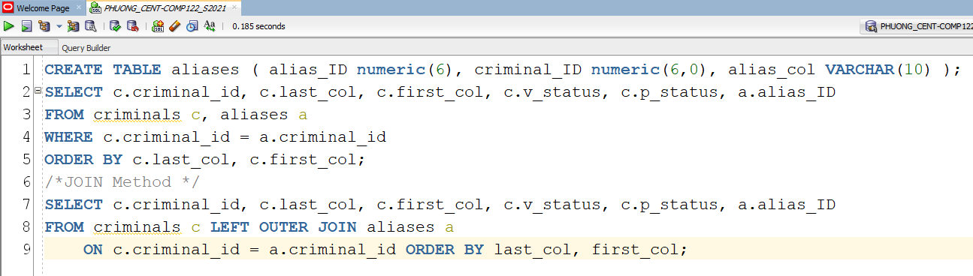

8.

SELECT crime_id, CLASSIFICATION, date_charged, hearing_date,

(hearing_date-date_charged)

FROM crimes

WHERE (hearing_date-date_charged) > 14;

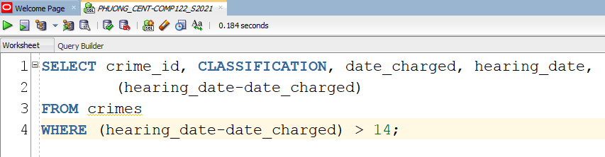

9.

SELECT criminal_ID, last, zip

FROM criminals

WHERE zip = 23510;

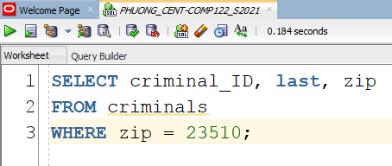

10.

SELECT crime_ID, criminal_ID, date_charged, hearing_date

FROM crimes

WHERE hearing_date IS NULL;

